📚 Udemy Courses Data Analysis Report
1. Introduction
This project analyzes Udemy’s course dataset to uncover insights into online learning trends. By exploring attributes such as course titles, subjects, pricing, enrollment, ratings, and publication dates, the study aims to identify patterns in learner preferences, course popularity, and market dynamics in the e-learning industry.
2. Dataset Overview
- Attributes (typical columns): Course ID, Title, Subject, Price, Number of Subscribers, Number of Reviews, Level (Beginner/Intermediate/Expert), Published Timestamp.
- Size: Large dataset covering thousands of courses across multiple subjects.
- Target Use: Trend analysis, recommendation insights, and pricing strategies.
3. Objectives
- Explore subject-wise distribution of courses.
- Analyze pricing strategies and their impact on enrollments.
- Identify top-performing courses based on subscribers and reviews.
- Detect trends in publication dates (e.g., growth of online learning over time).
- Build visualizations to highlight relationships between price, ratings, and popularity.
4. Tools & Libraries
- Python – core programming language
- Pandas & NumPy – data cleaning and manipulation
- Matplotlib & Seaborn – visualization
- Jupyter Notebook – documentation and reproducibility
5. Key Analyses
Exploratory Data Analysis (EDA)
- Distribution of courses by subject (e.g., Business, Web Development, Music).
- Price distribution and free vs. paid course comparison.
- Subscriber counts across different subjects.
Outlier Detection
- Identify courses with unusually high enrollments or reviews.
Visualizations (placeholders for figures)
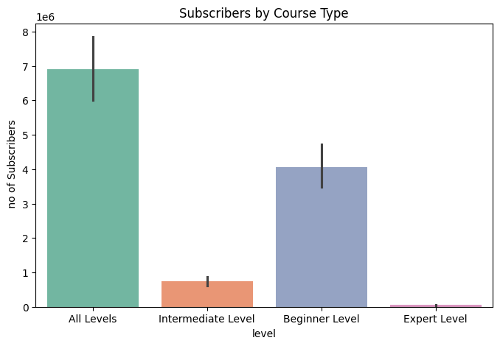
- Bar Chart: Subscribers by Course Type compares the popularity of Udemy courses across different levels

- Histogram: Distribution of course prices.
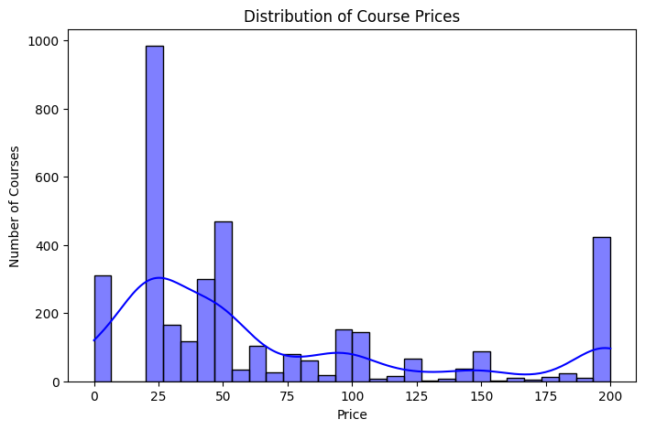
- Line Plot: Growth of courses published over time.

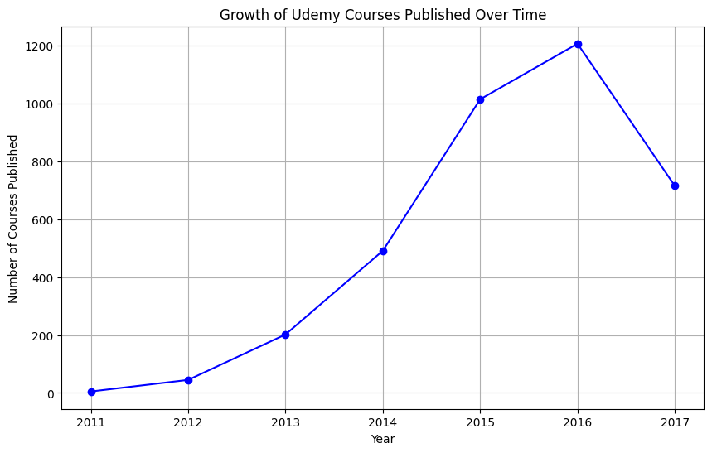

- Scatter Plot: Price vs. number of subscribers.

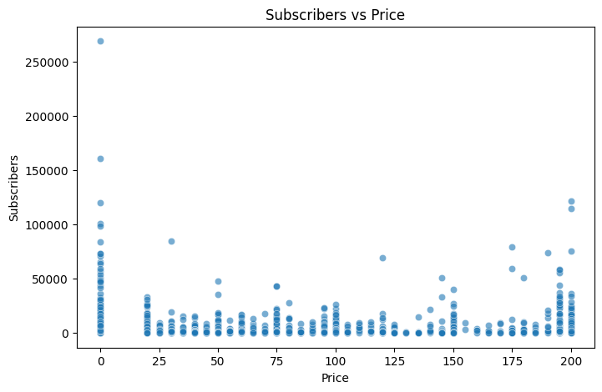
Statistical Analysis
- Correlation between price, reviews, and subscribers.
- Hypothesis testing: Do free courses attract significantly more subscribers than paid ones?
6. Insights
- Web Development and Business courses dominate the platform.
- Free courses attract higher enrollments but often fewer reviews compared to paid ones.
- Pricing strategies vary widely, with mid-range priced courses showing strong subscriber engagement.
- Publication trends indicate rapid growth in online learning after 2015.
7. Conclusion
This analysis demonstrates how Udemy’s dataset can be leveraged to understand learner behavior and course performance. By combining statistical methods, visualization, and trend analysis, the project provides actionable insights for instructors, learners, and stakeholders in the e-learning industry.

📈 Stock Data Analysis Report
1. Introduction
This project analyzes stock market data to uncover trends, volatility, and performance metrics. By applying statistical methods and visualization techniques, the study aims to support investment decisions and highlight market behavior over time.
2. Dataset Overview
- Attributes: Date, Open Price, Close Price, High, Low, Volume, Adjusted Close.
- Target Use: Time-series analysis of stock performance.
- Size: Daily records across multiple companies or indices.
3. Objectives
- Explore historical stock price trends.
- Detect volatility and outliers in trading activity.
- Compare performance across different companies or sectors.
- Visualize moving averages and technical indicators.
- Build predictive models for short-term price forecasting.
4. Tools & Libraries
- Python – core programming language
- Pandas & NumPy – data manipulation and numerical operations
- Matplotlib & Seaborn – visualization
- Scikit-learn / Statsmodels – statistical modeling and forecasting
- Jupyter Notebook – documentation and reproducibility
5. Key Analyses
- Exploratory Data Analysis (EDA):
  - Distribution of daily returns.
  - Correlation between stock prices and trading volume.
- Outlier Detection:
  - Identify unusual spikes in price or volume.
- Visualizations:
Box plot: Daily Price Range Distribution by Ticker compares the volatility of four major stocks: AAPL, MSFT, NFLX, and GOOG.
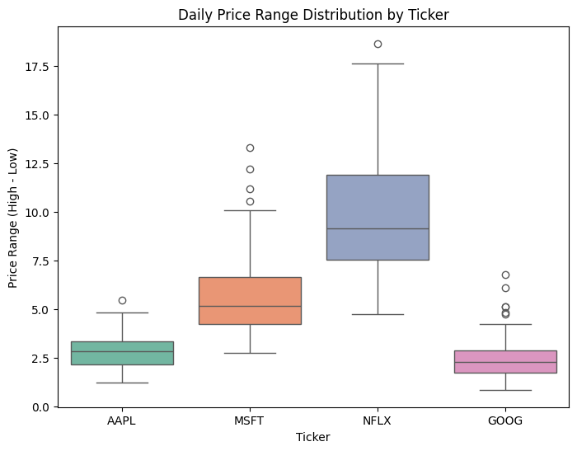

Line graph: Closing Prices Over Time tracks the stock performance of AAPL, MSFT, NFLX, and GOOG between February and May 2023.

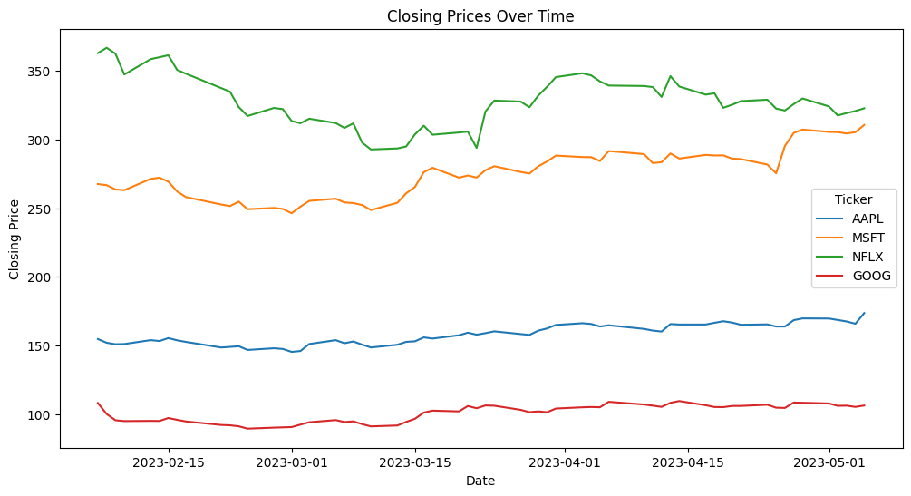

Heatmap: Correlation Matrix of Stock Features shows the relationships among key market variables: Open, High, Low, Close, Adjusted Close, and Volume.
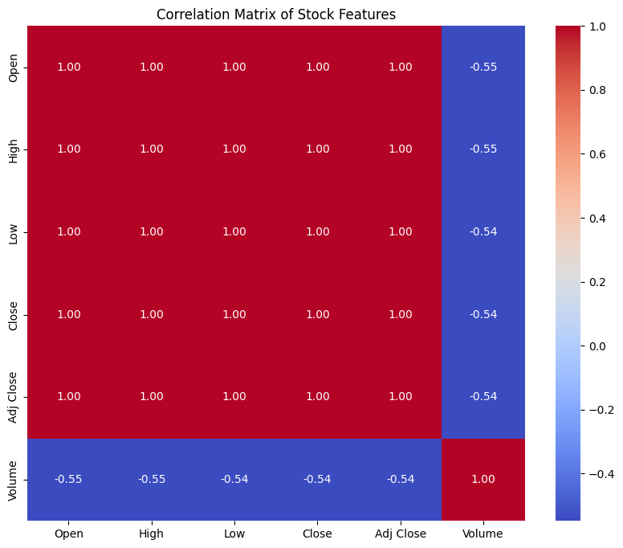

Pair plot (scatterplot matrix) : visualizes relationships among stock features: Open, High, Low, Close, and Volume.
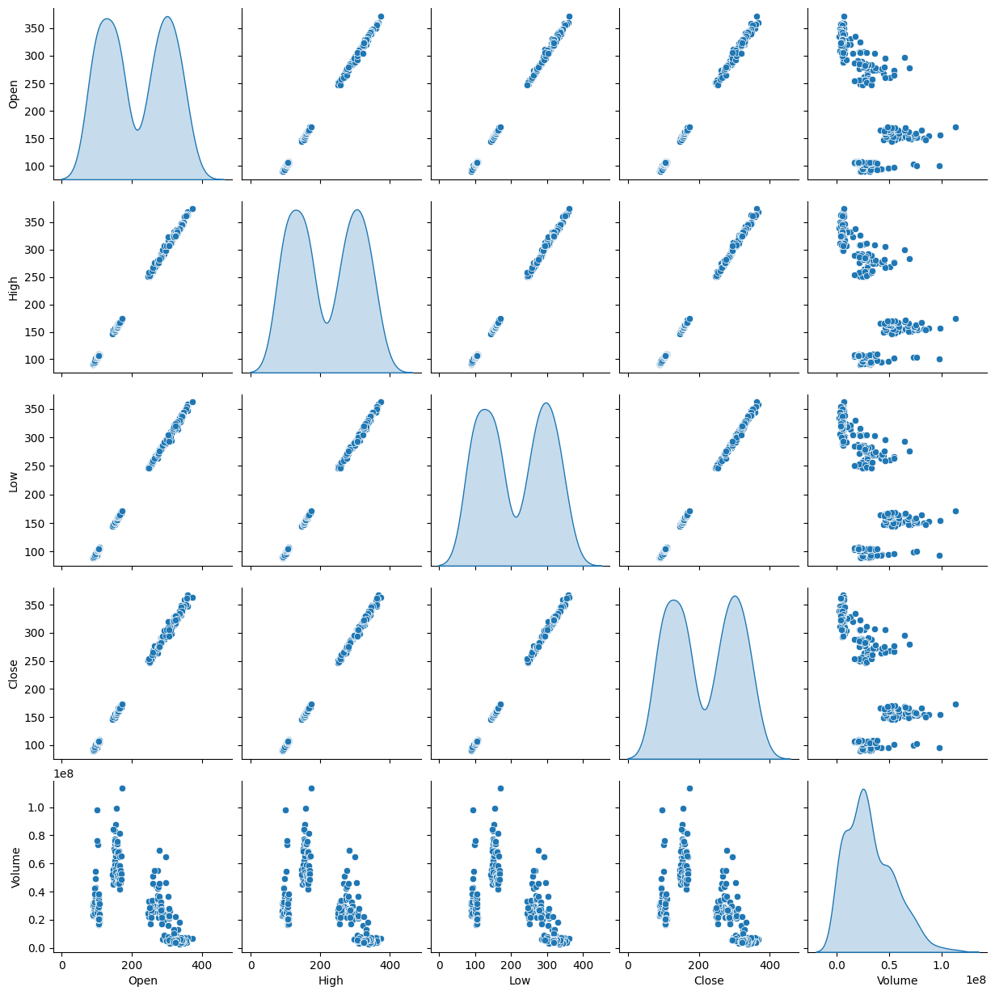

6. Insights
- Moving averages reveal long-term growth trends.
- Volatility analysis highlights periods of market instability.
- Correlation studies show sector-level dependencies.
- Predictive models provide short-term guidance but require caution due to market uncertainty.
7. Conclusion
This analysis demonstrates how stock data can be leveraged to understand market dynamics and support investment strategies. Combining statistical methods, visualization, and predictive modeling provides actionable insights for traders, analysts, and stakeholders.

🫀 Heart Disease Prediction Data Analysis Report

1. Introduction
This project applies data science techniques to patient health records to predict the likelihood of heart disease. By analyzing clinical features such as age, cholesterol, blood pressure, and exercise response, the study demonstrates how statistical methods and machine learning can support preventive healthcare and decision-making.
2. Dataset Overview
- Source: Heart Disease Prediction dataset
- Attributes: Age, Sex, Chest Pain Type, Blood Pressure, Cholesterol, Fasting Blood Sugar, EKG Results, Max Heart Rate, Exercise Angina, ST Depression, Slope of ST, Number of Vessels, Thallium Test
- Target Variable: Heart Disease (Presence/Absence)
- Size: 300+ patient records with mixed categorical and numerical features
3. Objectives
- Explore demographic and clinical factors influencing heart disease.
- Detect outliers in cholesterol and blood pressure.
- Visualize relationships between key variables (e.g., age vs. disease presence).
- Build predictive models to classify patients into “Presence” or “Absence.”
- Perform hypothesis testing to evaluate differences in risk factors.
4. Tools & Libraries
- Python – core programming language
- Pandas & NumPy – data cleaning and manipulation
- Matplotlib & Seaborn – visualization
- Scikit-learn – machine learning models
- Jupyter Notebook – documentation and reproducibility
5. Key Analyses
Exploratory Data Analysis (EDA)
- Age distribution shows higher prevalence in older patients.
- Cholesterol and blood pressure levels vary widely, with some extreme outliers.
- Gender-based differences observed in disease occurrence.
- Correlation heatmap highlights strong predictors such as chest pain type and exercise angina.
Outlier Detection
- IQR and Z-score methods applied to cholesterol and blood pressure.
- Extreme values flagged for medical review.
Visualizations (placeholders for figures)
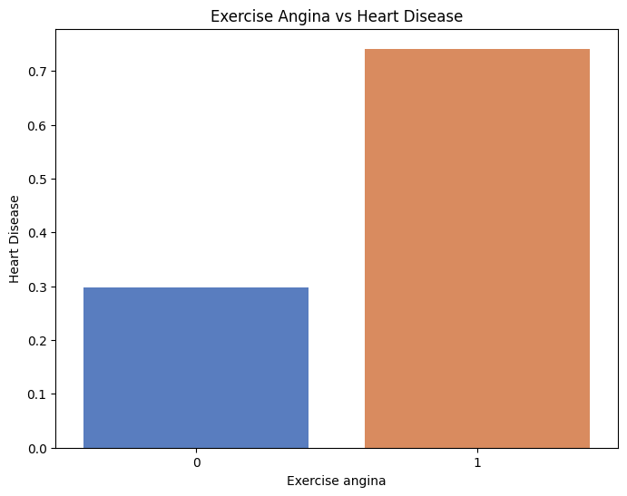
- Bar Chart: Heart disease prevalence by chest pain type.

Correlation Matrix : table that shows the correlation coefficients between multiple variables in a dataset.
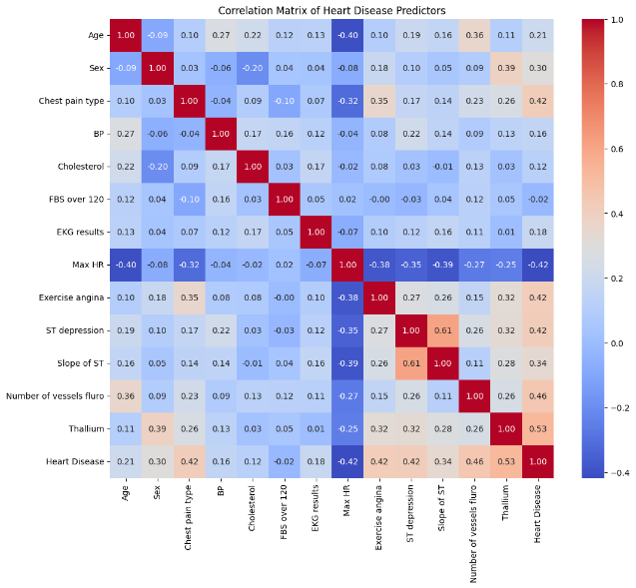

Histogram : Age Distribution shows how patient ages are spread across the dataset.
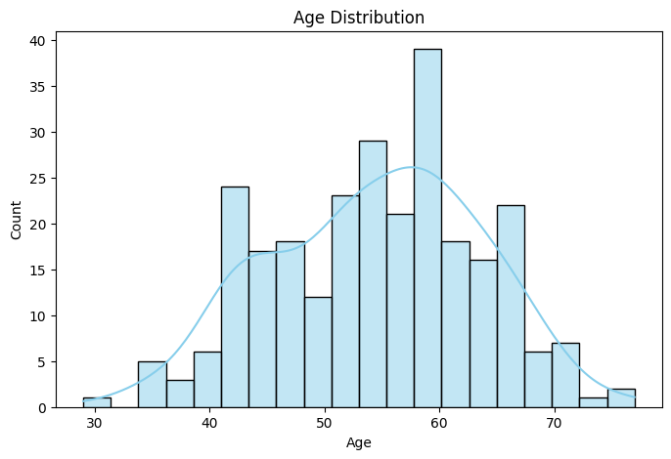

Bar chart :Chest Pain Type vs Heart Disease compares the frequency of different chest pain categories with the presence or absence of heart disease.
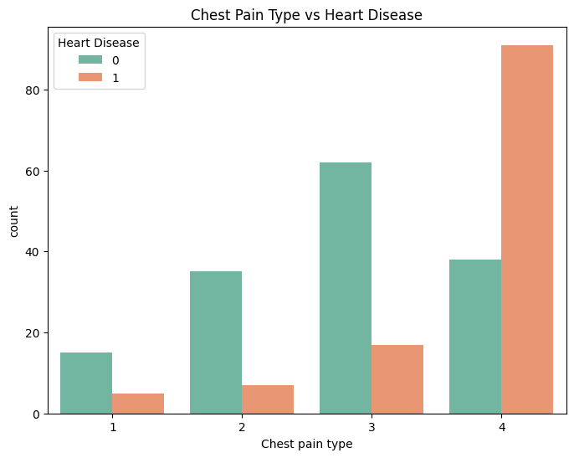

6. Insights
- Older patients and those with high cholesterol/blood pressure are at greater risk.
- Chest pain type and exercise-induced angina are strong predictors.
- Logistic regression provides interpretable coefficients, while Random Forest improves predictive performance.
- Outlier detection highlights extreme cholesterol values that may require medical attention.
7. Conclusion
This project demonstrates how patient health data can be leveraged to predict heart disease risk. Combining statistical methods, visualization, and machine learning provides actionable insights for clinicians and researchers. The predictive model serves as a decision-support tool, while the findings highlight key risk factors for targeted interventions.

🔋 Electric Vehicle Data Analysis Project

This project involves a comprehensive analysis of electric vehicle (EV) data using Python. The dataset includes various technical and performance specifications such as price, range, battery capacity, energy consumption, and more. The goal is to derive meaningful insights, visualize key relationships, detect outliers, and build a simple EV recommendation system. Statistical methods are also used to compare performance between leading EV manufacturers.

📊 Project Objectives:
- Filter and group EVs based on customer criteria (e.g., price and range).
- Analyze and compare EV specifications across different manufacturers.
- Detect outliers in energy consumption using statistical methods.
- Visualize the relationship between battery capacity and range.
- Build a recommendation class to suggest EVs based on user preferences.
- Perform hypothesis testing to compare engine power between brands (Tesla vs Audi).
- Provide actionable insights based on data exploration and statistical analysis.

🧰 Tools & Libraries Used:
- Python
- Pandas – data manipulation
- NumPy – numerical operations
- Matplotlib / Seaborn – data visualization
- Jupyter Notebook – for coding and documentation

📂 Project Structure:
- EV_Data_Analysis.ipynb – Main Jupyter Notebook with code, analysis, and visualizations.
- FEV-data-Excel.xlsx – Dataset used for analysis.
- README.md – Project overview and instructions.

🧪 Key Features:
- Interactive Filtering: Identify EVs under a given budget and with a desired range.
- Statistical Analysis: Outlier detection and t-tests for hypothesis evaluation.
- Recommendation Engine: Custom class to recommend top 3 EVs based on user input.
- Clear Visualizations: Plots and charts to support insights and findings.
- Data Storytelling: Narratives accompanying each task to explain the outcomes.

🎯 Outcome:
The analysis provides useful insights for customers, manufacturers, and stakeholders in the EV market. By exploring real-world vehicle specs, the project demonstrates how data-driven decisions can be made for EV selection and comparison.
Graph:
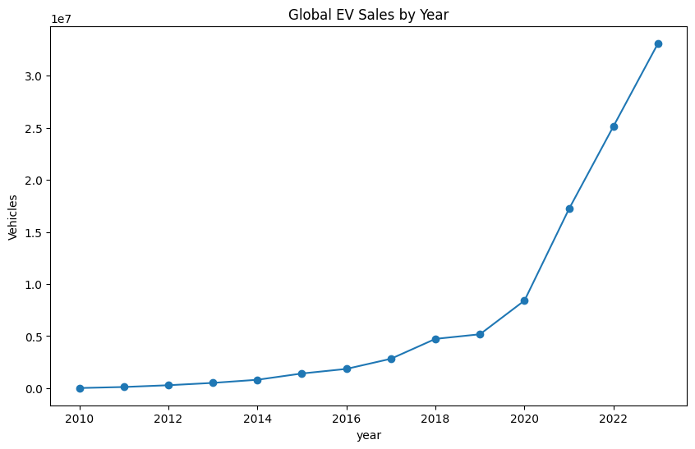
Line graph titled Global EV Sales by Year shows the growth in electric vehicle sales worldwide from 2010 to 2023. It highlights a steady rise in adoption, with a sharp surge after 2020, crossing 30 million units by 2023. Such a plot is valuable in data analysis projects because it clearly illustrates long-term trends, helps identify inflection points in market growth, and supports forecasting future adoption patterns in a visually intuitive way.

Stacked area chart titled EV Stock Growth by Powertrain shows how electric vehicle adoption has evolved from 2010 to 2023, broken down into BEVs, PHEVs, and FCEVs. It highlights BEVs as the dominant contributor, with PHEVs adding moderate growth and FCEVs remaining minimal. Such a plot is useful in data analysis projects because it allows clear visualization of category-wise contributions, helps compare technology adoption trends, and supports insights into market dynamics over time.
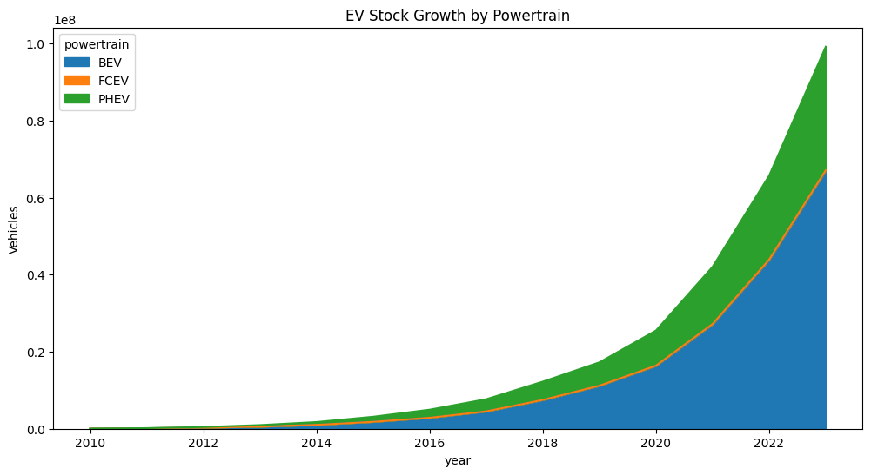

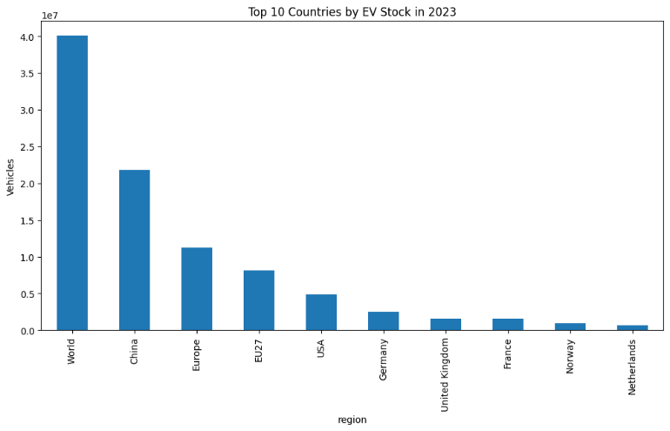
Bar chart titled Top 10 Countries by EV Stock in 2023 compares the number of electric vehicles across major regions and nations. It shows China and Europe leading the adoption, with the USA and individual European countries following at lower levels. Such a chart is useful in data analysis projects because it highlights regional disparities, identifies market leaders, and provides a clear comparative view of global EV distribution, making it easier to analyze adoption patterns and policy impacts.

Line graph titled BEV vs PHEV Sales Over Time compares the adoption trends of battery electric vehicles and plug-in hybrids from 2010 to 2023. It shows BEVs accelerating sharply after 2019, surpassing 22 million units by 2023, while PHEVs grow more steadily, reaching just over 10 million. Such a visualization is valuable in data analysis projects because it highlights comparative growth patterns, helps identify market preferences, and supports forecasting by showing which technology is gaining dominance over time.

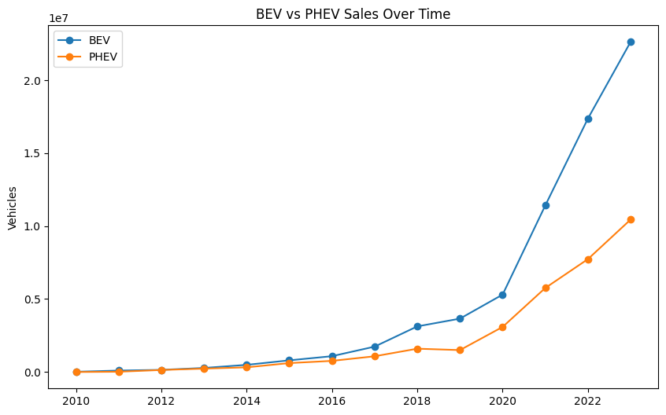

This pie chart titled EV Sales Distribution by Powertrain shows the market share of BEVs, PHEVs, and FCEVs. BEVs dominate with over two-thirds of total sales, PHEVs hold a substantial share, and FCEVs remain negligible. Such a chart is useful in data analysis projects because it provides a clear snapshot of category proportions, helps identify dominant technologies, and supports strategic insights into consumer preferences and market direction.
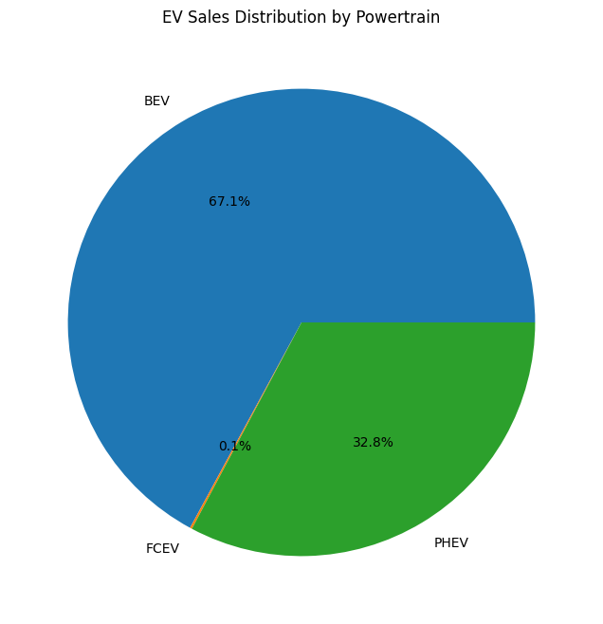

📈 Stock Data Analysis Report
1. Introduction
This project analyzes stock market data to uncover trends, volatility, and performance metrics. By applying statistical methods and visualization techniques, the study aims to support investment decisions and highlight market behavior over time.
2. Dataset Overview
- Attributes: Date, Open Price, Close Price, High, Low, Volume, Adjusted Close.
- Target Use: Time-series analysis of stock performance.
- Size: Daily records across multiple companies or indices.
3. Objectives
- Explore historical stock price trends.
- Detect volatility and outliers in trading activity.
- Compare performance across different companies or sectors.
- Visualize moving averages and technical indicators.
- Build predictive models for short-term price forecasting.
4. Tools & Libraries
- Python – core programming language
- Pandas & NumPy – data manipulation and numerical operations
- Matplotlib & Seaborn – visualization
- Scikit-learn / Statsmodels – statistical modeling and forecasting
- Jupyter Notebook – documentation and reproducibility
5. Key Analyses
- Exploratory Data Analysis (EDA):
  - Distribution of daily returns.
  - Correlation between stock prices and trading volume.
- Outlier Detection:
  - Identify unusual spikes in price or volume.
- Visualizations:
Box plot: Daily Price Range Distribution by Ticker compares the volatility of four major stocks: AAPL, MSFT, NFLX, and GOOG.

Line graph: Closing Prices Over Time tracks the stock performance of AAPL, MSFT, NFLX, and GOOG between February and May 2023.

Heatmap: Correlation Matrix of Stock Features shows the relationships among key market variables: Open, High, Low, Close, Adjusted Close, and Volume.

Pair plot (scatterplot matrix) : visualizes relationships among stock features: Open, High, Low, Close, and Volume.

6. Insights
- Moving averages reveal long-term growth trends.
- Volatility analysis highlights periods of market instability.
- Correlation studies show sector-level dependencies.
- Predictive models provide short-term guidance but require caution due to market uncertainty.
7. Conclusion
This analysis demonstrates how stock data can be leveraged to understand market dynamics and support investment strategies. Combining statistical methods, visualization, and predictive modeling provides actionable insights for traders, analysts, and stakeholders.

